Варіант №4

1) Вибрано варіант роботи в Docker.

docker pull cassandra

sudo docker ps

sudo docker exec -it cassandra-node bash

cqlsh

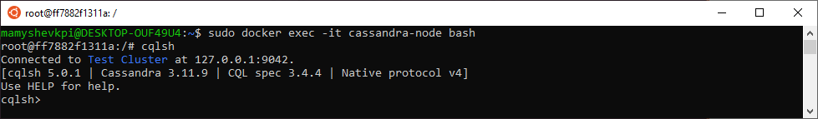

CREATE KEYSPACE GamesShopDB WITH replication = {'class': 'SimpleStrategy', 'replication_factor': '1'};



USE GamesShopDB;

CREATE TABLE ITEM (id UUID, category text, producer text, model text, price float, etc map <text, text>, PRIMARY KEY(category, price, model, id));



INSERT INTO item(id, category, model, producer, price, etc) values (now(), 'infantry', 'Tactical Squad', 'Games Workshop', 1000, {'role': 'Troops'});

INSERT INTO item(id, category, model, producer, price, etc) values (now(), 'infantry', 'Kosmopehota', 'Tehnolog', 100, {'fraction': 'Kosmoarmiya'});

INSERT INTO item(id, category, model, producer, price, etc) values (now(), 'infantry', 'Razrushyteli', 'Tehnolog', 150, {'fraction': 'Kosmoarmiya'});

INSERT INTO item(id, category, model, producer, price, etc) values (now(), 'transport', 'KosmoBeTeeR', 'Tehnolog', 250, {'fraction': 'Kosmoarmiya'});

INSERT INTO item(id, category, model, producer, price, etc) values (now(), 'tank', 'Kosmotank', 'Tehnolog', 350, {'fraction': 'Kosmoarmiya'});

INSERT INTO item(id, category, model, producer, price, etc) values (now(), 'infantry', 'Devastator Squad', 'Games Workshop', 1200, {'role': 'Heavy Support' });

INSERT INTO item(id, category, model, producer, price, etc) values (now(), 'transport', 'Rhino', 'Games Workshop', 2500, {'role': 'Dedicated Transport'});

INSERT INTO item(id, category, model, producer, price, etc) values (now(), 'tank', 'Predator', 'Games Workshop', 4000, {'role': 'Heavy Support'});

INSERT INTO item(id, category, model, producer, price, etc) values (now(), 'flyer', 'Thunderhawk', 'Games Workshop', 5000, {'role': 'Flyer'});

INSERT INTO item(id, category, model, producer, price, etc) values (now(), 'tank', 'Tank-Krab', 'Tehnolog', 500, {'fraction': 'Inoplanetnye Moluski'});

INSERT INTO item(id, category, model, producer, price, etc) values (now(), 'heavy infantry', 'Tyazhelaya Kosmopehota', 'Tehnolog', 200, {'fraction': 'Kosmoarmiya'});

INSERT INTO item(id, category, model, producer, price, etc) values (now(), 'heavy infantry', 'Terminator Squad', 'Games Workshop', 2000, {'role': 'Elite'});

INSERT INTO item(id, category, model, producer, price, etc) values (now(), 'heavy infantry', 'Deathwing Squad', 'Games Workshop', 2500, {'role': 'Elite'});

INSERT INTO item(id, category, model, producer, price, etc) values (now(), 'infantry', 'Razvedchiki', 'Tehnolog', 75, {'fraction': 'Kosmoarmiya'});

INSERT INTO item(id, category, model, producer, price, etc) values (now(), 'infantry', 'Scout Squad', 'Games Workshop', 900, {'role': 'Troops'});

DESCRIBE item;

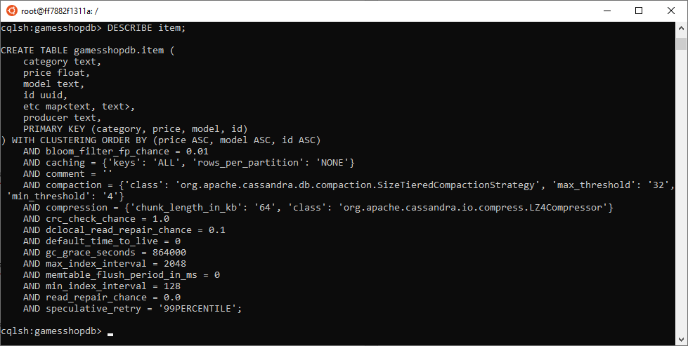

2)

SELECT * FROM item Where category='infantry' ORDER BY price ASC;

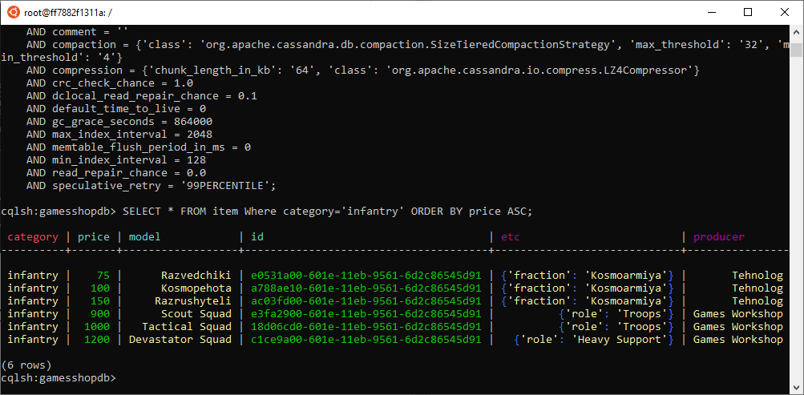

3)

SELECT * FROM item Where category = 'infantry' and price<1300;

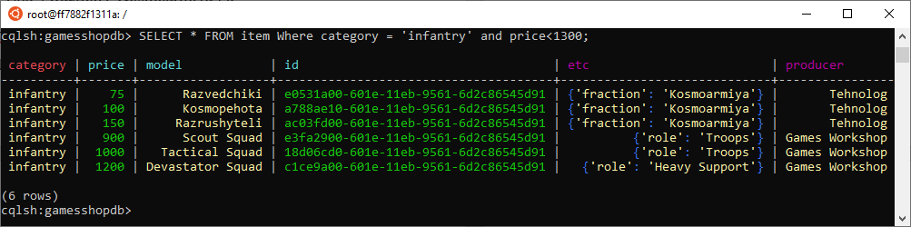

SELECT * FROM item Where category='infantry' and price>899 and price<1301;

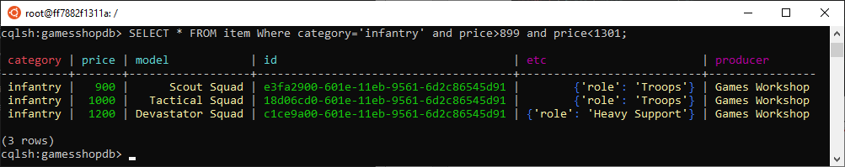

4)

COPY item(id, category, model, producer, price, etc) TO 'export.csv';

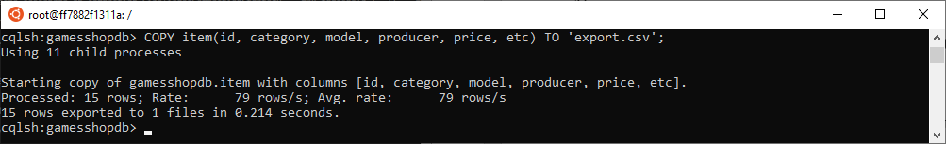

CREATE TABLE ITEMetc (id UUID, category text, producer text, model text, price float, etc map <text, text>, PRIMARY KEY(etc, price, model, id));

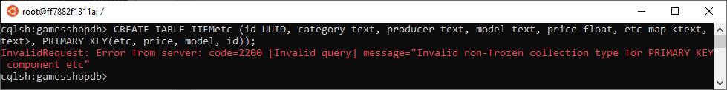

Нажаль, дана операція неможлива, так як, неможливо зробити головним ключем значення з типом map.

SELECT * FROM item Where etc contains key 'fraction';

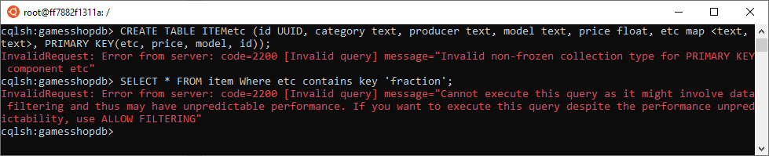

Нажаль, дана операція неможлива без використання ALLOW FILTERING

5)

UPDATE item SET etc['role']= 'Elite' where category = 'infantry' and price=900 and model = 'Scout Squad' and id= e3fa2900-601e-11eb-9561-6d2c86545d91;

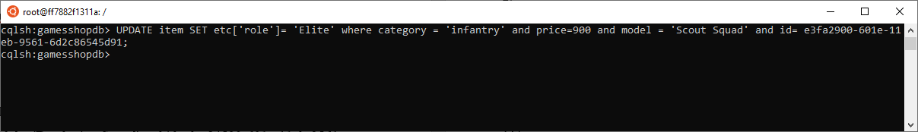

SELECT * FROM item where category = 'infantry' and price=900 and model = 'Scout Squad' and id= e3fa2900-601e-11eb-9561-6d2c86545d91;

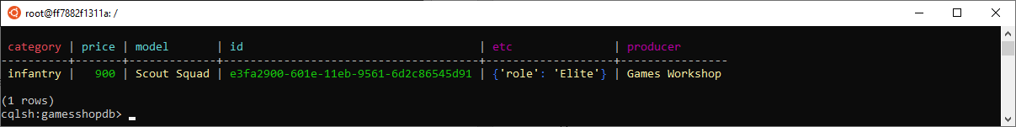

UPDATE item SET etc['fraction']='Dark Angels' where category = 'heavy infantry' and price=2500 and model = 'Deathwing Squad' and id= dcc84590-601e-11eb-9561-6d2c86545d91;



SELECT * FROM item where category = 'heavy infantry' and price=2500 and model = 'Deathwing Squad' and id= dcc84590-601e-11eb-9561-6d2c86545d91;

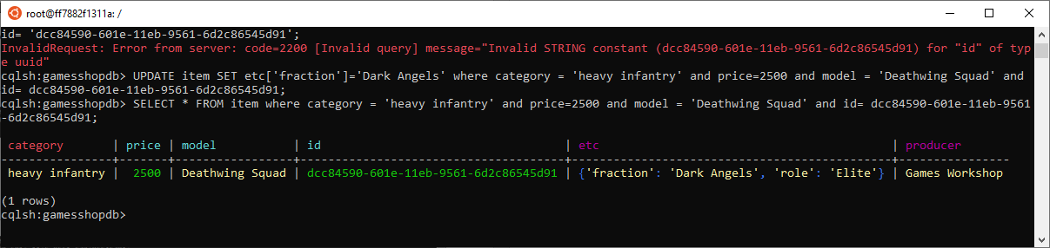

UPDATE item SET etc['fraction']= null where category = 'heavy infantry' and price=2500 and model = 'Deathwing Squad' and id= dcc84590-601e-11eb-9561-6d2c86545d91;



SELECT * FROM item where category = 'heavy infantry' and price=2500 and model = 'Deathwing Squad' and id= dcc84590-601e-11eb-9561-6d2c86545d91;

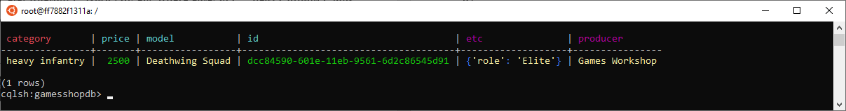

CREATE TABLE ORDERS (ordid UUID, user text, date timestamp, cartid list<UUID>, sum float, PRIMARY KEY (user, date, ordid)) WITH CLUSTERING ORDER BY (date ASC);  


INSERT INTO orders(ordid, user, date, cartid, sum) values (now(), 'Ivan Ivanov', '2021-01-14', [dcc84590-601e-11eb-9561-6d2c86545d91], 2500);

INSERT INTO orders(ordid, user, date, cartid, sum) values (now(), 'Petro Petrov', '2021-01-16', [e0531a00-601e-11eb-9561-6d2c86545d91, a788ae10-601e-11eb-9561-6d2c86545d91, ac03fd00-601e-11eb-9561-6d2c86545d91], 345);

INSERT INTO orders(ordid, user, date, cartid, sum) values (now(), 'Ivan Ivanov', '2021-01-21', [d9693c10-601e-11eb-9561-6d2c86545d91, 18d06cd0-601e-11eb-9561-6d2c86545d91], 3000);

INSERT INTO orders(ordid, user, date, cartid, sum) values (now(), 'Vasyl Vasylevskii', '2021-01-21', [e3fa2900-601e-11eb-9561-6d2c86545d91, 18d06cd0-601e-11eb-9561-6d2c86545d91], 1900);

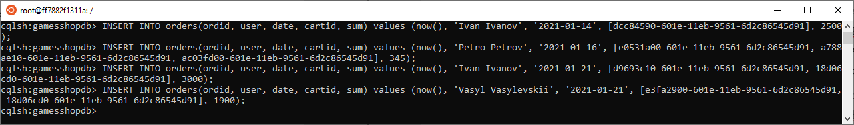

1)

DESCRIBE orders;

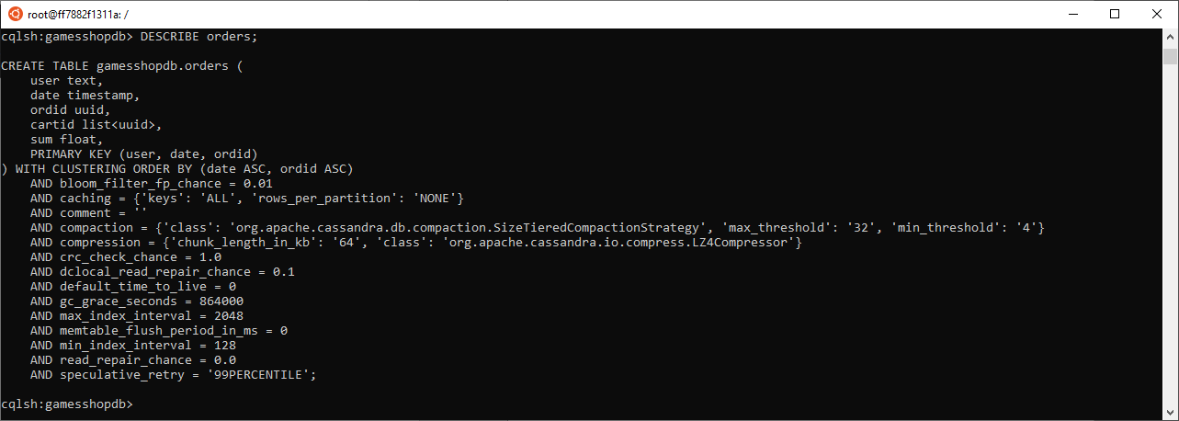

2)

Select * from orders where user='Ivan Ivanov' ORDER by date asc;

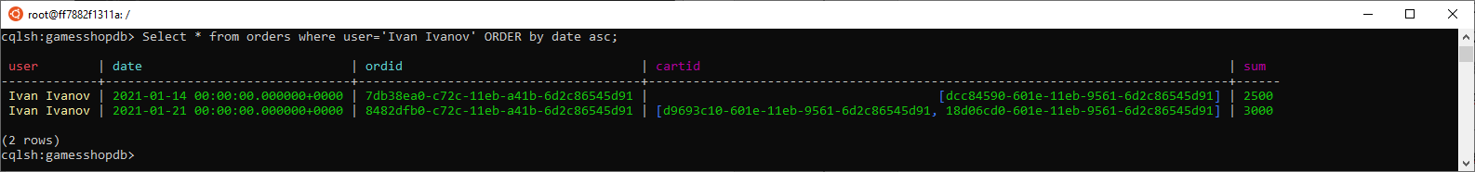

3)

Select * from orders where user='Ivan Ivanov' and cartid contains dcc84590-601e-11eb-9561-6d2c86545d91 ALLOW FILTERING;

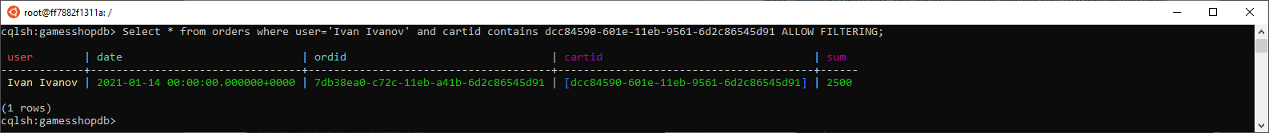

4)

Select * from orders where user = 'Ivan Ivanov' and date>'2021-01-01' and date<'2021-01-31';

Select count(*) from orders where user = 'Ivan Ivanov' and date>'2021-01-01' and date<'2021-01-31';

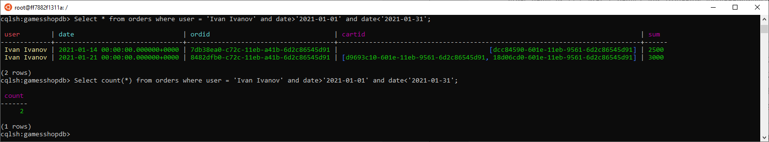

5)

Select user, avg(sum) from orders group by user;

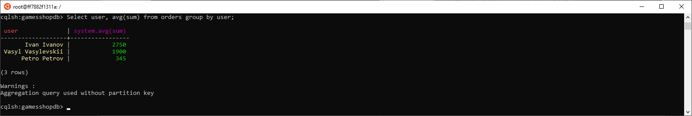

6)

Select user, sum(sum) from orders group by user;

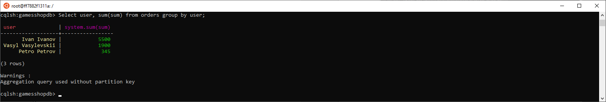

7)

Select user, max(sum) from orders group by user;

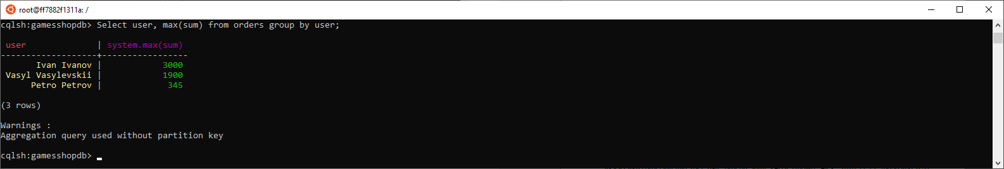

8)

UPDATE orders SET cartid = cartid + [c1ce9a00-601e-11eb-9561-6d2c86545d91], sum=4200 where ordid= 8482dfb0-c72c-11eb-a41b-6d2c86545d91 and user = 'Ivan Ivanov' and date = '2021-01-21';

Select * from orders where ordid= 8482dfb0-c72c-11eb-a41b-6d2c86545d91 and user = 'Ivan Ivanov' and date = '2021-01-21';

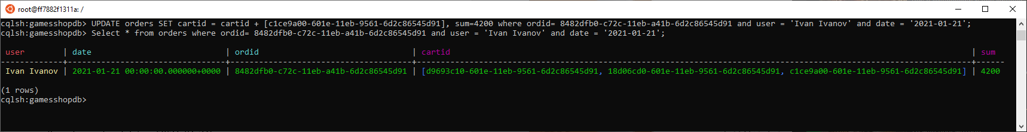

9)

Select ordid, writetime(sum) from orders;

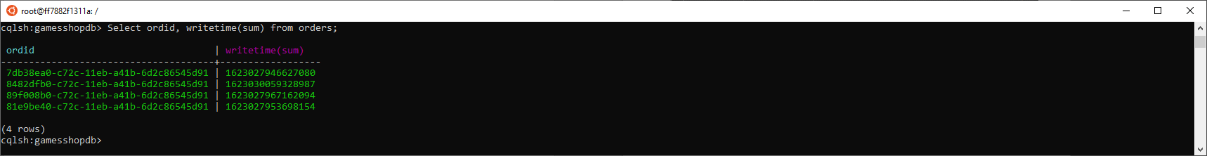

10)

INSERT INTO orders(ordid, user, date, cartid, sum) values (now(), 'Petro Petrov', '2021-01-24', [e3fa2900-601e-11eb-9561-6d2c86545d91], 900) using ttl 1000;

Select * from orders;

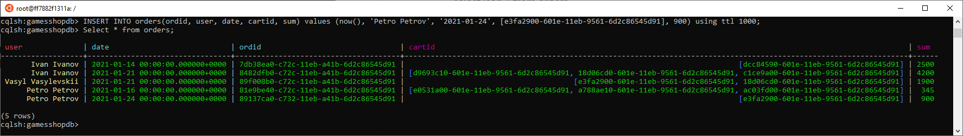

11)

Select json * from orders;

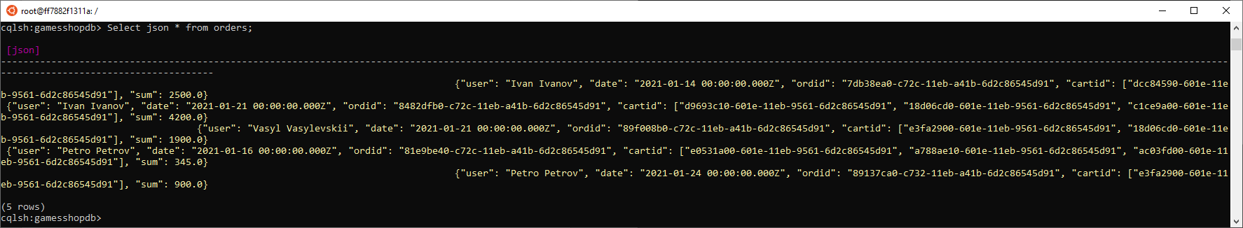

12)

insert into orders JSON ' {"user": "Oleksii Alekseev", "date": "2020-01-26 00:00:00.000Z", "ordid": "8992dfb0-c72c-11eb-a41b-6d2c86545d91", "cartid": ["e3fa2900-601e-11eb-9561-6d2c86545d91", "18d06cd0-601e-11eb-9561-6d2c86545d91"], "sum": 1900.0}';

